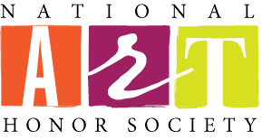

National Art Honor Society

Craig High School Chapter
National Art Honor Society members must be a Junior or Senior Student, who has taken one year of art and maintained a 3.0 cumulative grade point average.
NAHS Members give back to their school and local community by participating in community service based projects that focus on creating awareness and appreciation of the arts. Past and present activities include murals in Craig and out in the community, eyeglass donation boxes for the Knights of Columbus, a mosaic bench for the Craig Sculpture Garden, work on developing and landscaping the Craig Sculpture Garden, face painting during homecoming, face painting at various community events, decorating and carving pumpkins for the Salvation Army’s Fall Festival, annually decorating a holiday tree that is on display in Craig’s Main Entrance, creating awards honoring talented artists within our community for JPAC, and raising money to send members to school going on in the visual arts.

Chapter Dues
Juniors $5.00
Seniors $17.00 (additional charge covers Honor Cord cost)
Through community service, Senior Members earn honor cords that are presented at an end of the year induction ceremony.

Club Advisors
Mrs. Amy Cossette and Mrs. Lori Barry
Contact Information:
Mrs. Cossette 608-743-5420 Email: acossette@janesville.k12.wi.us
Mrs. Barry 608-743-5422 Email: lbarry@janesville.k12.wi.us

